

School Of
Electrical and Electronics Engineering
Minor Project-2

Report On

Design and development of SPI protocol for MATOMAC

(SEMI-KSHA SEMICONDUCTORS (P.) LTD.)

By:
Sl.No | Name | USN
01 | Rahul Teli | 01FE21BEE008
02 | Malhar Kulkarni | 01FE21BEE016
03 | Chandru Thomare | 01FE21BEE022
04 | Chandrashekar R Angadi | 01FE21BEE031

Semester: V, 2023-2024
Under the Guidance of:
Dr. Saroja Siddamal

K.L.E SOCIETY’S
KLE Technological University,
HUBBALLI-580031
2023-2024
SCHOOL OF ELECTRICAL AND ELECTRONICS ENGINEERING
CERTIFICATE

This is to certify that project entitled “Design and development of SPI protocol for MATOMAC
” Is a bonafide work carried out by the student team of” Rahul G Teli- 01FE21BEE008, Malhar Kulkarni- 01FE21BEE016, Chandru Thomare - 01FE21BEE022, Chandrashekar R Angadi - 01FE21BEE031”. The project report has been approved as it satisfies the requirements with respect to the minor project work prescribed by the university curriculum for BE (VI Semester) in School of Electrical and Electronics Engineering of KLE Technological University for the academic year 2023-2024.

Dr. Saroja Siddamal Dr. Saroja Siddamal Dr. Basavaraj S Anami
Guide Head of School Registrar
External Viva:
Name of Examiners Signature with date
1.
2.

ACKNOWLEDGMENT
We would like to express our sincere gratitude to KLE Technological University, Hubballi for providing us the facilities and resources to carry out our project on Design and development of SPI protocol for MATOMAC. We are especially thankful to the Head of School of Electrical and Electronics, Dr. Saroja V Siddamal, for her constant motivation and guidance throughout this endeavour. We would also like to thank our project guide Dr. Saroja V Siddamal for her invaluable insights, feedback, and direction at every stage of this project. Her vast knowledge and experience in this field steered us in the right direction whenever we faced any difficulties. In addition, we are grateful to the entire VLSI Design faculty team for clarifying our doubts patiently and helping us gain a thorough understanding of advanced concepts related to our project. We also appreciate the lab technicians for promptly addressing all our queries on the software tools and ensuring smooth progress of simulations. Finally, we would like to express our heartfelt gratitude towards our parents and family members for their unconditional love, emotional support and encouragement that gave us the motivation to work diligently on this challenging yet fulfilling project. We dedicate our project work to them as without their blessings, none of this would have been possible. Once again, we thank everyone who was directly or indirectly involved in making our efforts come to fruition. This acknowledgment reaffirms our sincere appreciation.
- Rahul G Teli, Malhar Kulkarni, Chandru Thomare, Chandrashekar R Angadi

ABSTRACT

As embedded systems grow more complex, effective communication between components becomes critical for overall system reliability and efficiency. The serial peripheral interface (SPI) has emerged as a popular bus protocol for achieving high-speed synchronized data transfer with reduced pin requirements. This project focuses on Design and development of SPI protocol for MATOMAC. The SPI controller is implemented in Verilog HDL and enables communication with external peripherals. It supports essential features including full-duplex data transmission, programmable clock polarity and phase options, interrupt generation and arbitration logic for multi-master configurations. A detailed register set with configurable control bits and data buffers allows flexibility to connect to a wide range of SPI-based sensors, ADCs, displays as per application requirements. Comprehensive testing procedures in simulation validate error-free functionality for corner cases. This simplifies integration challenges in embedded product designs and serves as a vital building block for realizing more complex SoC architectures. The modular Verilog implementation, register specifications and test methodology documented in this project will facilitate future enhancements as well as integration of the design into variants of SPI-IP based SoCs.

Contents
- Introduction
  - Motivation
  - Objectives
  - Literature survey
  - Problem statement
  - Application in societal context
  - Organization of report

- System Design
  - Functional Block Diagram of SPI-IP

- Implementation details
  - Architecture of SPI Protocol
  - SoC Design
    - Firmware Description
    - Hardware Description
    - Port Mapping
  - Register Description
    - Control Register1
    - Control Register2
    - Status Register
    - Baud Rate Register

- Results and discussions
  - Result Analysis
  - Simulation Results and Analysis

- Conclusions and future scope
  - Conclusion
  - Future scope

Chapter 1
Introduction
The Serial Peripheral Interface (SPI), a protocol designed for the efficient, synchronous communication between devices, is fundamental in the realm of embedded systems. Originating in the mid-1980s by Motorola for inter-chip communication, SPI has become a staple in facilitating dialogue between various slow-speed devices, including sensors, analog-to-digital converters, real-time clocks, and memory modules like flash memory. This protocol, characterized by its full-duplex communication ability, leverages a select line alongside separate clock and data connections to manage multiple devices, thereby providing an uninterrupted data transfer capability that supports up to 32 bits of simultaneous transmission.

  - Motivation
Designing and developing a Serial Peripheral Interface (SPI) protocol for MATOMAC presents a fantastic opportunity to enhance communication efficiency within SEMI-KSHA SEMICONDUCTORS' systems. The SPI protocol is renowned for its simplicity, speed, and versatility, making it an ideal choice for interfacing various integrated circuits (ICs) within MATOMAC.
- Streamlined Communication: A well-designed SPI protocol will establish a clear and concise communication channel between MATOMAC's core components. This translates to faster data exchange, improved system responsiveness, and potentially reduced power consumption.
- Enhanced Performance: By optimizing the SPI protocol for MATOMAC's specific requirements, it is possible to unlock significant performance gains. This could involve minimizing data transfer times, reducing latency, and ensuring reliable data transmission.
- Futureproofing Design: A well-structured and documented SPI protocol lays a solid foundation for future enhancements and integrations within MATOMAC. This promotes maintainability, scalability, and easier collaboration within your team.

  - Objectives
Objectives for designing and developing an SPI protocol for MATOMAC at SEMI-KSHA SEMICONDUCTORS (P.) LTD. are
Requirement Specifications
1. 4-wire SPI devices have four signals (MOSI, MISO, SCLK, SS/CS)
2. Data Transmission (Speed)
3. Clock Polarity and Clock Phase (Multimode operation)
4. Multi -slave concept implementation

1.3 Literature survey
NXP-SPI Block Guide V03.06 by Motorola,Inc.
The overview, features, and modes of operation are covered in the introduction. The master and
slave wiring connection, which consists of MOSI (Master Out Slave In), MISO (Master In Slave
Out), SCK (Line for Clock Signal), and SS/CS (Slave Select/Chip Select), is described in the
external signal description. SPI Control Register- 1, SPI Control Register- 2, SPI Baud Rate
Register, SPI Status Register, and SPI Data Register are among the registers described in the
memory map. Master and Slave modes, transmission formats, clock phase controls, and polarity
controls are all included in the functional description. It includes the CPHA=0 and CPHA=1
transfer formats, SPI baud rate generation, slave select output. [4].

Design and Implementation of a High-Speed Serial Peripheral Interface
A synchronous protocol called Serial Peripheral Interface enables serial communication between
a slave and a master device. This work aims to give a detailed account of an implementation of
a high-speed SPI Master/Slave. The designs are based on SPI Block Guide V03.06 by Motorola.
The design phases are methodically developed, beginning with the preliminary specifications
and ending with the final physical design. The entire design is mapped into Xilinx’s Virtex 5
FPGA chips using Verilog 2001. A prominent serial protocol for low- to medium-speed data
stream transfers within and between chips is serial peripheral interface (SPI). It facilitates communication between a microcontroller and several additional devices, such as external DACs,
ADCs, and EEPROMs [1].

IP Core of Serial Peripheral Interface (SPI) with AMBA APB Interface
In this paper, the SPI design has been successful in obtaining a maximum 16 MHz frequency
and a complete duplex 8-bit serial data transfer that is solely for master mode. MODELSIM
is used to model the job, while QUARTUS lite 16 is used to synthesis it. The RTL netlist
viewer from QUARTUS light 16’s findings demonstrate that data is transported from one submodule
to another submodule. This design is a straightforward interface that connects easily to
microcontroller’s (I/O) port, and it can be used to connect to an APB [5].

Implementation of SPI Protocol in FPGA
This paper describes the implementation of the Serial Peripheral Interface (SPI) protocol on
a Field Programmable Gate Array (FPGA). State machine diagrams are used in the implementation
of the SPI Master and SPI Slave components. Very High-Speed Integrated Circuits
Hardware Descriptive Language (VHDL) is used for the coding. After obtaining an acknowledgment,
the received data is examined and the simulated data is displayed [7].

Design and Implementation of Serial Peripheral Interface Protocol Using Verilog
HDL
This study aims to design and build a master and slave SPI (serial peripheral interface) using
Verilog HDL. One kind of serial communication protocol that transports synchronous serial data
in full duplex mode is the serial peripheral interface, or SPI. In SPI, there are two different communications modes: master and slave. The Xilinx ISE design suite 13.3.1 is used to simulate and
synthesize the entire design while the master device creates a serial clock and the slave devices
are permitted with individual slave select lines. A hardware/firmware communications protocol
called Serial to Peripheral Interface (SPI) was created by Motorola and eventually embraced by
other companies in the sector. SPI is also referred to as a” four wire” serial bus occasionally.
Many microprocessor/microcontrollers peripheral chips employ the Serial Peripheral Interface,
or SPI-bus, a straightforward 4-wire serial communications interface that allows controllers and
peripheral devices to connect with one another. SPI is primarily designed to facilitate communication
between a host CPU and peripherals, but it can also be used to connect two processors.
When the SPI bus is fully operational, it is a synchronous data link configuration featuring a
Master/Slave interface. SPI allows for the possibility of both single-master and multi-master
protocols. Typically, only the PCB uses the SPI Bus. The SPI Bus was created to transport
data quickly and efficiently between different IC chips [6].

Design and Analysis of Serial Peripheral Interface for Automotive Controller
A popular communication protocol called Serial Peripheral Interface (SPI) enables serial data
transfer across a small distance between a slave and a master device. However, there are issues
with clock synchronization and poor speed in the existing Serial Peripheral Interface implementation.
A few factors related to automotive must be considered to improve the
interface device’s performance. The design, simulation, verification, and optimization of SPI
based on automotive interface device standards are presented in this work. It includes improved
power dissipation efficiency and a faster interface device. The speed and area attained are far
better than the SPI’s present design. Because of the technical relationship between power and
speed in VLSI design, even though the total dissipation obtained is more than the already used
SPI architecture, it is acceptable [2].

Design and Simulation of SPI Master / Slave Using Verilog HDL
This paper’s goal is to use Verilog HDL to develop and simulate an SPI (serial peripheral interface)
master and slave. It is a widely used interface for attaching peripherals to microprocessors
and to each other. Although various Motorola microcontrollers support transfers of any range
of blocks between two and sixteen bits at a time, most literature claims that the
interface can only be utilized for eight- or sixteen-bit block data transfers. Control signals can
be used to implement data transfers of more than sixteen bits at a time with ease due to the
serial nature of the interface. Either the slave or the master protocol can be implemented by
the SPI. Up to 32 separate SPI slaves can be under the control of the SPI when it is set as a
master. The transmit and receive register widths can be adjusted to be wider than sixteen bits.
As many devices as there are pins on the core microcontroller can be connected using SPI. The
communication rate amongst ICs is substantially higher. With SPI, full duplex communication
is carried out [8].

Design and Verification Serial Peripheral Interface (SPI) Protocol for Low Power
Applications
High-speed data communication between devices is made possible by Serial to Peripheral Interface
(SPI) technology, which was intended to replace parallel connections and eliminate the
need to route parallel buses around PCBs. When connecting its initial 68000-based microcontroller
unit to peripheral functions in the late 1970s, Motorola was the first firm to identify the
circuit technology SPI, which was eventually adopted by other companies in the industry. SPI
gained popularity as a communication protocol due to its ease of interface and speed, which
facilitates data transfers with ease. SPI has established a strong position for itself in embedded
systems, whether they be system-on-a-chip (SOC) processors or other microcontrollers like PIC
and AVR, as well as more sophisticated 32-bit processors like those that use MIC, Power PC,
or ARM. These chips typically come with SPI controllers, which can operate in either slave or
master mode. SPI is occasionally used for communication in chip-based or field programmable
gate array devices. SPI is therefore a widely utilized technology nowadays for communicating
with peripheral devices when fast data transfer under real-time limitations is required.
Intel is actively working on the Enhanced Serial Peripheral Interface bus (eSPI), a replacement
for their low pin count (LPC) bus.In contrast to systems using low pin counts, enhanced
SPI was designed to allow greater throughput than LPC, lower working voltages to 1.8 volts to
enable smaller chip manufacturing processes, and allow enhanced SPI to share serial peripheral
interface flash devices with the host. On the other hand, low pin counts (LPC) buses prevented
LPC peripherals from using firmware hubs. Enhanced serial peripheral interface also allows
system designers to trade off cost and performance.[3]
  - Problem statement
This project aims at Design and development of SPI protocol for MATOMAC. This is supplemented by a rigorous phase of testing and validation to ascertain the efficacy of the implemented design.

  - Application in societal context
The applications within MATOMAC at SEMI-KSHA SEMICONDUCTORS (P.) Ltd. can have a significant ripple effect on various aspects of society.
1. Technological Advancement:
- Faster Innovation: Efficient communication within MATOMAC, enabled by the SPI protocol, can accelerate the development cycle for new semiconductor technologies. This translates to faster innovation in areas like:
  - Medical devices: Faster development of pacemakers, hearing aids, and other medical electronics that rely on advanced semiconductors.
  - Consumer electronics: Creation of more powerful and efficient smartphones, laptops, and other consumer devices.
  - Communication infrastructure: Advancements in cellular networks, internet connectivity, and data transmission technologies.
2. Improved Efficiency in Various Fields:
- Industrial Automation: Optimized communication in MATOMAC-based systems can lead to more efficient industrial processes in factories and production lines. This translates to:
  - Increased production output
  - Reduced waste and energy consumption
  - Improved product quality
- Transportation: SPI-enabled systems could be used in:
  - Autonomous vehicles – for reliable communication between sensors and control units
  - Smart traffic management systems – to optimize traffic flow and reduce congestion
- Healthcare: Improved communication within medical devices like:
  - Diagnostic equipment – for faster and more accurate diagnoses
  - Treatment devices – for precise control and real-time monitoring
3. Job Creation and Economic Growth:
- The development and application of efficient semiconductor technologies like those potentially created by MATOMAC can stimulate economic growth by:
  - Creating new jobs in the semiconductor industry and related fields
  - Fostering innovation that leads to the development of new products and services
  - Contributing to a stronger and more competitive global economy

1.6 Organization of report
• 1: Introduction
It includes motivation towards the project, objectives of project, literature survey done towards the problem statement, defining the problem statement, and looking at the application in a societal context, followed by project planning.
• 2: System design
This topic includes the High-level functional block diagram and description of the functional blocks.
• 3: Implementation details
This topic contains detailed information about implementation. It also Includes specifications used to design and propose the final system architecture. It contains the Hardware Interfacing Description with in-depth details in Firmware, Hardware Description, and the Port Mapping. It also includes the detailed information about the Registers Description and Finite State Machine.
• 4: Results and Discussions
This chapter includes the conclusion and results of implementation.
.5: Conclusion
This is the concluding topic that includes project closure and epilogue along with- the future scope of our project.

Chapter 2

System Design of SPI Integration

This chapter elucidates the block-level design of the Serial Peripheral Interface (SPI) within a System on Chip (SoC) architecture. The focal point of this design is the seamless integration of the Processor ET1032 with the SPI controller and SPI master to facilitate efficient data transfer to the SPI slave. The architecture underpins the transition of data handling from parallel to serial transmission, underscoring the system’s capability to bridge the computational core with peripheral communication modules effectively.

- Functional Block Diagram of SPI-IP
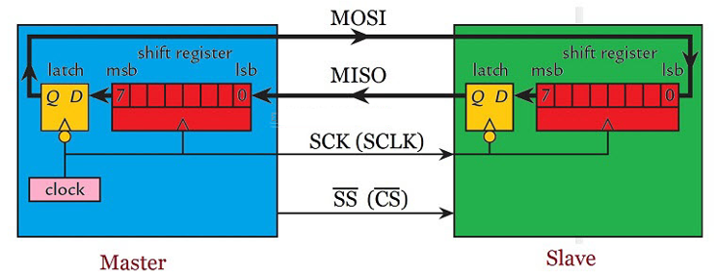
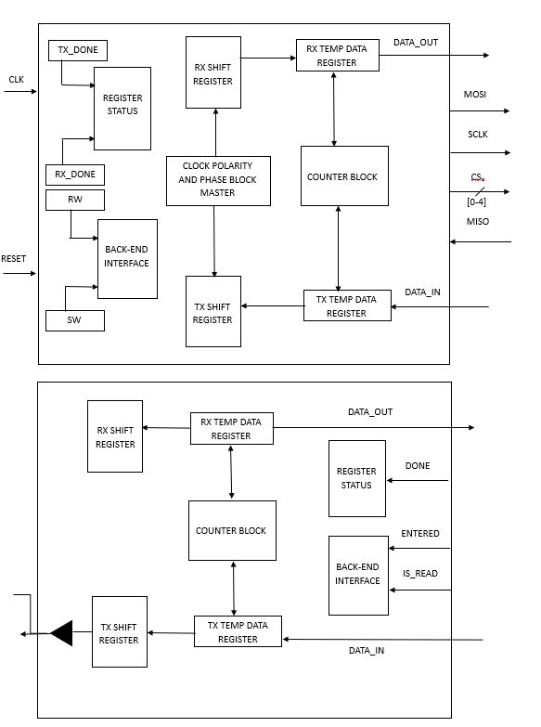
Block Diagram of SPI
Figure 2.1:

The system's architecture is predicated on a tripartite structure comprising the Processor ET1032, the SPI Controller, and the SPI Master. At the outset, data is orchestrated in a parallel format from the Processor to the SPI Controller, ensuring high-speed data handling within the core system. Subsequently, the SPI Controller interfaces with the SPI Master, maintaining the parallel data framework to uphold the integrity and speed of data processing. The culmination of this data journey is marked by the transition from parallel to serial transmission as the SPI Master communicates with the SPI slave, signifying the core-to-peripheral data exchange pivotal to SPI’s operational paradigm.

SPI Controller

SPI Controller receives values for PADDR and PWDATA from the Processor. Depending on the PADDR values, the two control registers and the baud rate registers are configured, thereby the read or write operations are decided. This block provides different values of frequencies of clock as input to the Master block based on the SPIBDR register bits.

SPI Master

The signals SCLK, MOSI and SS are the output from the master and MISO is the input to the master. The data register consists of input write data register, which is transferred to the slave serially through the MOSI line based on SCLK and the read data register receives the input through the MISO line based on SCLK.

Data Transfer Mechanism
Data transfer within the system initiates with the Processor ET1032 transmitting data in a parallel format to the SPI Controller, which, in turn, processes and transmits this data to the SPI Master while maintaining the parallel configuration. The SPI Master then converts this parallel data into a serial format, facilitating the transmission to the SPI slave. This structured approach to data handling, transitioning from parallel to serial transmission, epitomizes the system’s design philosophy, optimizing for speed and efficiency within the embedded SoC environment.

Chapter 3
Implementation details
3.1 Architecture of SPI Protocol
In this Chapter, we infer the detailed information about implementation. It also includes
Finite State Machine and final system architecture. There is a Finite State Machine of SPI
Master.
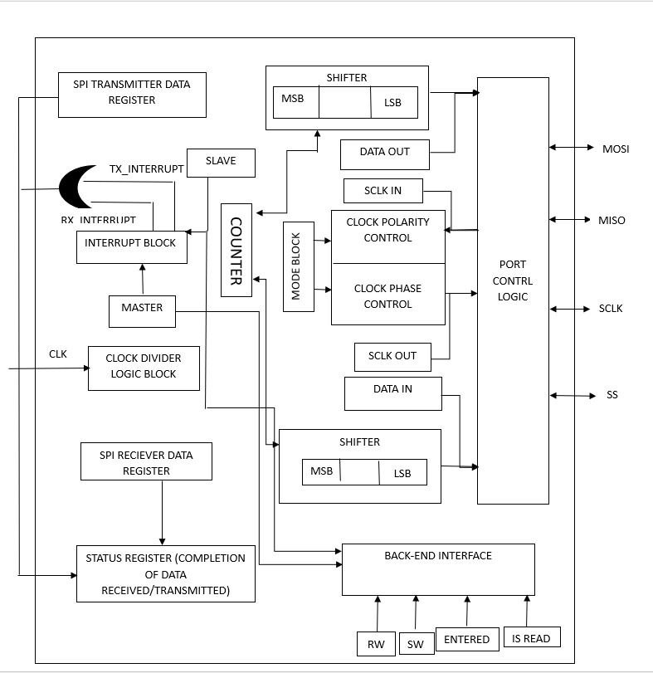
The figure 3.1 shows the Architecture of SPI, that includes the Processor and SPI top module.
Initially the processor sends clk p, reset, addrb signals to the SPI top module, based on which
the registers are configured and based on this register configuration the data transfer takes place
serially from master to slave through MOSI.

3.2.1 Firmware Description
Firmware is written in Ubuntu. There are four files in Firmware i.e., SPI.c, main.c, config.h,
SPI.h.
• The C code is written for the SPI in Firmware.
• The base address of SPI is 0x30000600 and it is declared in config.h.
• The variables declared in SPI.h are SPI CR , SPI PWDATA, SPI PRDATA, SPI SR takes
the addressess as 0x00, 0x04, 0x08, 0x0c respectively.
• In SPI.c the values are assigned to these variables. In main.c, the function of SPI.c is
called.
• To build the code, open the terminal in the file location and enter the command ”./build.sh”.
• After successful compilation, a soc 32.mif file with binary instructions is generated in
miff gen tool folder.
• Copy these binary instructions from 257 line till the end and paste it in a new file with
mif extension.
• This generated mif file is updated in Boot memory i.e., mem 0.mif of the processor.
Figure 3.2: Binary Instructions

3.2.2 Hardware Description
Figure 3.3: Block diagram of SoC
Sys Top and clock wizard are the two components of SoC. Sys Top consists of the RISC-V
Processor, SPI Peripheral and two memory locations.
1. Clock Wizard : Internal clock that synchronizes and regulates how quickly instructions
are carried out across all the parts. The processor needs a set amount of clock ticks, also
known as clock cycles, to complete each instruction.
2. RISC V Processor : An open-source, scalable CPU architecture with a modular design
is called RISC-V. It is becoming more and more popular in a variety of applications, from
high-performance computers to embedded devices. It is efficient and flexible
3. Memory : Two memory blocks on the SoC are used to load and store data and instructions.
4. SPI : SPI Peripheral interacts with Processor and other blocks in SoC.
5. These Processor variables are port mapped with the SPI Peripheral which is described
next.

The steps after generating the .mif file from the Firmware are:
• First update the generated mif from the Firmware into the Processor memory i.e mem 0.mif.
• Then the Processor fetches the instructions from the memory, decodes the instruction and
updates the values of different variables in the Processor as per the decoded instruction.

3.2.3 Port Mapping

Figure 3.4: Port Mapping

The Processor fetches the instructions from its boot memory, decodes the instructions and stores the data in its signals. All these Processor control signals, data signals are
port mapped with SPI signals.

3.2Register Description
Integral to the SPI's functionality are several key registers: Control Register 1 (SPICR 1), Control Register 2 (SPICR 2), the Status Register (SPISR), and the Baud Rate Register.

SPICR 1 facilitates primary control operations, such as SPI enable/disable, master/slave mode selection, and clock polarity/phase settings.

SPICR 2 primarily deals with serial pin control distinctions between master and slave modes.
SPISR indicates transaction statuses, including interrupt flag, transmit empty flag, and mode fault occurrences.

The Baud Rate Register governs the SPI communication speed, adjustable through specific preselection and selection bits to match system requirements.

3.1.1Control Register 1[8-bit][Read/Write]:
- SPIE — SPI Interrupt Enable Bit
This bit enables SPI interrupt requests, if SPIF or MODF status flag is set.
1 = SPI interrupts enabled.
0 = SPI interrupts disabled.
FUNCTIONS:
- The SPIE bit enables and disables all SPI interrupts. Setting SPIE to 1 allows interrupts from SPI transmission (TXIE) and reception (RXIE) to occur. Setting SPIE to 0 disables all SPI interrupts.
- SPE — SPI System Enable Bit
This bit enables the SPI system and dedicates the SPI port pins to SPI system
functions.
1 = SPI enable, port pins are dedicated to SPI functions.
0 = SPI disabled (lower power consumption).

FUNCTIONS:
- The SPE (SPI Enable) bit enables and disables the SPI peripheral/module. Setting SPE to 1 enables the SPI peripheral so it can send and receive data. Setting SPE to 0 disables the SPI peripheral.

- SPTIE — SPI Transmit Interrupt Enable
This bit enables SPI interrupt requests, if SPTEF flag is set.
1 = SPTEF interrupt enabled
0 = SPTEF interrupt disabled.
FUNCTIONS:
- The SPTIE (SPI Transmit Interrupt Enable) bit enables and disables transmit interrupts in SPI. Setting SPTIE to 1 allows the SPI module to generate an interrupt when a transmission is complete. This signals the processor that transmission buffer is empty and new data can be written. Setting SPTIE to 0 disables transmit interrupts.
- MSTR — SPI Master/Slave Mode Select Bit
This bit selects, if the SPI operates in master or slave mode. Switching the SPI from
master to slave or vice versa forces the SPI system into idle state.
1 = SPI is in Master mode.
0 = SPI is in Slave mode.
FUNCTIONS:
- The MSTR (Master/Slave Select) bit configures the SPI module as either a master or slave. Setting MSTR to 1 configures the SPI module as a master which generates the serial clock and controls the data flow. Setting MSTR to 0 configures the SPI module as a slave which receives the serial clock and data from a master SPI device.

- CPOL — SPI Clock Polarity Bit
This bit selects an inverted or non-inverted SPI clock. To transmit data between SPI
modules, the SPI modules must have identical CPOL values.
1 = Active-low clocks selected. In idle state SCK is high.
0 = Active-high clocks selected. In idle state SCK is low.
FUNCTIONS:
- The CPOL (Clock Polarity) bit sets the clock polarity for SPI communication. Setting CPOL to 0 configures the clock to be low when not transmitting data. This is the idle state. Setting CPOL to 1 configures the clock to be high when not transmitting data. The clock polarity needs to match the requirements of the SPI slave device.
- CPHA — SPI Clock Phase Bit
This bit is used to select the SPI clock format. In master mode, a change of this bit
will abort a transmission in progress and force the SPI system into idle state.
1 = Sampling of data occurs at even edges (2,4, 6...16) of the SCK clock
0 = Sampling of data occurs at odd edges (1,3, 5...,15) of the SCK clock
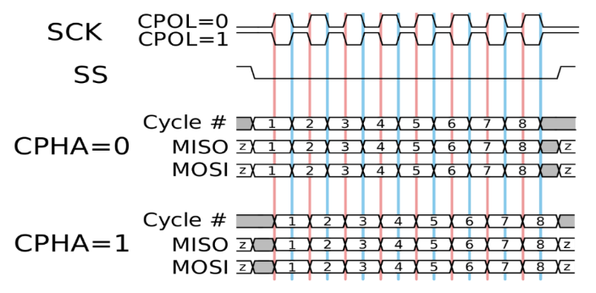
FUNCTIONS:
- The CPHA (Clock Phase) bit selects which clock edge data is sampled on. Setting CPHA to 0 configures the SPI module to sample data on the first edge of the clock period. This is useful when data is available at the beginning of the clock cycle. Setting CPHA to 1 configures sampling at the second edge of the clock period. This allows one clock cycle between shifting data and sampling. The phase needs to match the SPI slave device requirements.

- LSBFE — LSB-First Enable
This bit does not affect the position of the MSB and LSB in the data register. Reads
and writes of the data register always have the MSB in bit 7.
1 = Data is transferred least significant bit first.
0 = Data is transferred most significant bit first.
FUNCTIONS:
- The LSBFE (LSB First Enable) bit controls the bit order for SPI data transfers. Setting LSBFE to 1 configures the SPI module to send the least significant bit (LSB) first in the data transfer. This is the default and most common configuration. Setting LSBFE to 0 configures the SPI module to send the most significant bit (MSB) first. The bit order needs to match the requirements of the SPI slave device.
- SSOE — Slave Select Output Enable
The SS output feature is enabled only in master mode, if MODFEN is set

FUNCTIONS:
- The SSOE (Slave Select Output Enable) bit enables or disables the slave select (SS) pin output from the SPI module. Setting SSOE to 1 enables the SS output. This allows the SPI module to send the SS signal to an SPI slave device to select it before transferring data. Setting SSOE to 0 disables the SS output pin, preventing slave selection.
3.1.1SPI Control Register 2 [8 bit] [Read/Write]:
- The MODFEN bit enables or disables mode fault detection. Setting MODFEN to 1 allows detection of mode faults in master mode. Setting it to 0 disables mode fault detection.

1 = SS port pin includes MODF feature in Master mode
0 = SS port pin is not used by the SPI in Master mode

FUNCTIONS:
- The MODFEN (Mode Fault Enable) bit enables or disables mode fault detection in the SPI module. Setting MODFEN to 1 allows the SPI module to detect mode faults and generate interrupts if there is a mode configuration issue between master and slave. Setting MODFEN to 0 disables mode fault detection.
- The BIDIROE bit controls the output enable for the MOSI and MISO pins in bidirectional mode. It enables the output buffer for the MOSI pin in master mode and the MISO pin in slave mode when set to 1.
1 = Output buffer is enabled
0 = Output buffer is disabled

FUNCTIONS:
- The BIDIROE (Bidirectional Output Enable) bit enables or disables the output buffers on the MOSI and MISO pins when using bidirectional SPI communication. Setting BIDIROE to 1 enables the output drivers for the MOSI pin in master mode and the MISO pin in slave mode. This allows sending and receiving data. Setting BIDIROE to 0 disables the output buffers which isolates the pins.

- SPISWAI (SPI Stop in Wait Mode) bit is employed for power conservation during wait mode.

The SPIWAITE bit controls whether the SPI clock stops in wait mode. Setting SPIWAITE to 1 will halt the SPI clock when the device enters wait mode. Setting it to 0 allows the SPI clock to continue operating in wait mode.

FUNCTIONS:
- The SPISWAI (SPI Stop in Wait Mode) bit controls whether the SPI clock stops when the microcontroller enters wait mode. Setting SPISWAI to 1 will halt the SPI clock generation when in wait mode. This reduces power consumption. Setting SPISWAI to 0 allows the SPI clock to continue running in wait mode so that SPI communications are uninterrupted.

- SPC0 — Serial Pin Control Bit 0

FUNCTIONS:
The SPC0 (SPI Pin Control 0) bit configures the SPI for either unidirectional or bidirectional communication. Setting SPC0 to 1 enables bidirectional mode, allowing simultaneous data transmission and reception through the MOSI and MISO pins. Setting SPC0 to 0 enables unidirectional mode where MOSI is output and MISO is input for half-duplex communication.
3.1.2SPI Baud Rate Register [8 bit]:
The SPPR2–SPPR0 (SPI Baud Rate Preselection) and SPR2–SPR0 (SPI Baud Rate Selection) bits determine the baud rates for the SPI communication, as illustrated in the table below. In master mode, modifying these bits will interrupt a transmission in progress, compelling the SPI system to transition into the idle state. In summary, these bits are responsible for setting the baud rate for SPI communication, and in master mode, any changes to these bits will terminate an ongoing transmission and put the SPI system into an idle state.

Functions of the SPPR2–SPPR0 bits:
- The SPPR bits (SPPR2, SPPR1, SPPR0) configure the baud rate prescaler which sets the SPI communication speed. Writing to these bits calculates the baud rate by dividing the peripheral clock frequency by the prescaler value. Changing the SPPR bits aborts any SPI transaction in progress and resets the communication.
3.1.3 SPI Status Register [8 bit] [Only Read & Not Write]:
- The SPIF (SPI Interrupt Flag) bit is raised once a received data byte has been successfully transferred into the SPI Data Register. To clear this flag, one must read the SPISR register with SPIF set, followed by a subsequent read access to the SPI Data Register.

When SPIF is set to 1, it indicates that new data has been copied to SPIDR.
When SPIF is set to 0, it signifies that the transfer is not yet complete
Functions of the SPIF bit:
- The SPIF (SPI Interrupt Flag) bit signals when data has been received in SPI. Setting SPIF to 1 allows the SPI module to generate an interrupt when a data reception is complete, indicating new data is available to read. Setting SPIF to 0 disables receive interrupts. The SPIF flag needs to be cleared after each receive event.
- The SPTEF bit indicates when the SPI transmit data register is empty. Reading SPTEF can check if the transmit register is empty before writing new data to it. SPTEF needs to be cleared by reading the status register after transmitting, which resets the interrupt flag before loading new transmit data..

When SPTEF is set to 1, it indicates that the SPI Data register is empty.
When SPTEF is set to 0, it indicates that the SPI Data register is not empty.

FUNCTIONS:
- The SPTEF (SPI Transmit Empty Flag) bit indicates if the transmit data buffer is empty in the SPI module. Reading SPTEF can check if the buffer is empty before writing new transmit data. SPTEF can also be used to trigger interrupts when the buffer becomes empty to signal readiness to accept more data. The flag needs clearing after reading and before writing new outbound data.

- The MODF bit flags a mode fault condition when SS goes low while in master mode if mode fault detection is enabled via MODFEN. It is cleared by reading the status register with MODF set then writing to the control register.
When MODF is set to 1, it indicates that a mode fault has occurred.
When MODF is set to 0, it signifies that no mode fault has occurred
FUNCTIONS:
- The MODF (Mode Fault Flag) bit indicates if a mode fault condition occurred in SPI communication. When set, it flags to the software that there is an SPI mode configuration mismatch between master and slave devices. MODF needs to be cleared by reading the status register and writing to the control register 1 to resume normal operation. Mode fault detection must be enabled by setting the MODFEN bit to use MODF.

3.1.4SPI Data Register [8 bit]:
The SPI Data Register serves a dual role as both the input and output register for SPI data. Writing to this register enables the queuing and transmission of a data byte. In the case of a SPI configured as a master, a queued data byte is transmitted immediately after the completion of the previous transmission.

Here are the key points regarding the behaviour of the SPI Data Register:
Transmission: When a byte is written to the SPI Data Register, it is queued and transmitted promptly if the SPI is configured as a master.
Received Data Validity: The data present in the SPIDR becomes valid when the SPIF (SPI Transfer Complete Flag) is set.
Clearing SPIF and Receiving Data: If SPIF is cleared and a byte has been received, the received byte is transferred from the receive shift register to the SPIDR, and SPIF is set.
Unserviced SPIF and Subsequent Reception: If SPIF is set and not serviced, and a second byte has been received, the second received byte remains valid in the receive shift register until the initiation of another transmission.

3.4 Finite State Machine

Figure 3.10: SPI Master FSM
The above figure depicts the SPI Master Finite State Machine. The Master block will be in idle
state until the reset pin is low and the system enable bit SPE is set. Once these bits are set it
will proceed to setup state. From setup state it will either move to the write state or read state
depending on MSTR and SPC0 bit. If both are set to high, it will move to write state, else it
will move to read state.

Chapter 4: Results and Discussions on SPI Protocol Verification
In this Chapter, the verification of the protocol through the simulation results and testing
the prototype on FPGA is discussed.
4.1 Result Analysis
The RTL coding for SPI protocol is written using Verilog HDL. The Vivado simulator is
used to observe the waveforms. The Write waveform of the SPI in the SOC is shown in Figure
4.2.
4.1.1 SoC Top Module
Figure 4.1: SoC Top Module Block

4.2 Simulation Results and Analysis
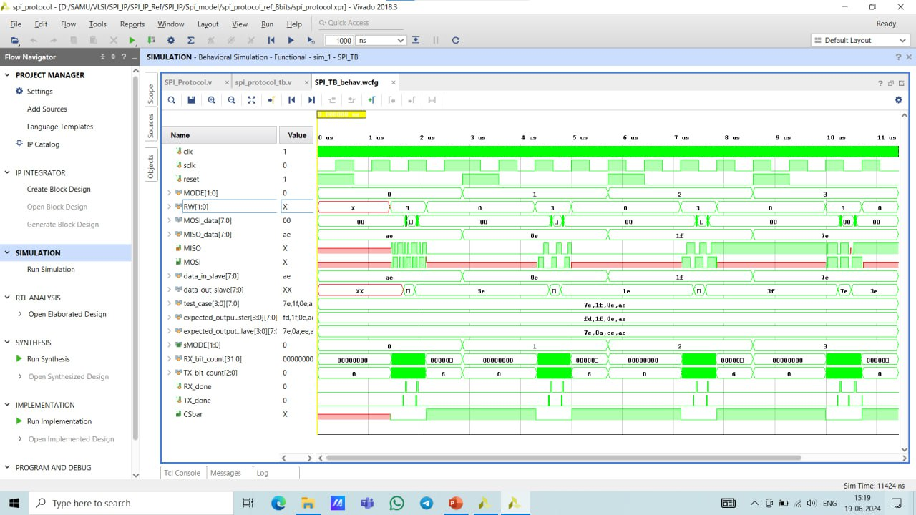
Figure 4.2: Analysis of SPI Write Operation in SoC

The above figure determines the input PWDATA data that is fetched from the Processor
and is transferred from Master through the MOSI line with respect to the sclk where MSB
is transferred first.

Chapter 5

Conclusions and future scope
This chapter provides a synthesis of the project's achievements and outlines the path forward, highlighting the project’s closure, key accomplishments, and the envisioned future developments in the domain of Serial Peripheral Interface (SPI) within System on Chip (SoC) architectures.

5.1 Conclusion
This project embarked on designing and implementing an interface between the processor and peripheral devices, with a keen emphasis on the Serial Peripheral Interface (SPI). The venture was twofold: to dissect the operational dynamics of SPI and to delve into the design intricacies associated with its implementation. By employing Verilog HDL for the SPI's implementation and the Universal Verification Methodology (UVM) for its verification, we mapped out the foundational elements of SPI—its operational principles, the configuration of its registers, and the initiation and management of serial communication between the master and selected slave devices. The project successfully delineated a comprehensive process for setting up an efficient SPI communication environment, alongside providing a detailed overview of the UVM-based verification platform for rigorously testing the SPI Design Under Test (DUT).

5.2 Future scope
Looking ahead, the project opens several avenues for broader application and deeper exploration within the field of RISC-V based SoC Design. The adaptability and efficiency of the SPI protocol evident from this project underscore its potential for broader applications, ranging from simple device control to complex data transfer systems within diverse SoC configurations. The project’s future directions include.

Bibliography
[1] N Anand, George Joseph, Suwin Sam Oommen, and R Dhanabal. Design and implementation
of a high-speed serial peripheral interface. In 2014 International Conference on Advances in
Electrical Engineering (ICAEE), pages 1–3. IEEE, 2014.
[2] Izhar Izzudin bin Jamaludin and Hasliza binti Hassan. Design and analysis of serial peripheral
interface for automotive controller. In 2020 IEEE Student Conference on Research and
Development (SCOReD), pages 498–501. IEEE, 2020.
[3] S. Choudhury. Design and verification serial peripheral interface (SPI) protocol for low power
applications. 2014.
[4] SPI Block Guide. Spi block guide v03. 06. S12SPIV3. pdf, 2003.
[5] Muhammad Hafeez and Azilah Saparon. Ip core of serial peripheral interface (spi) with
amba apb interface. In 2019 IEEE 9th Symposium on Computer Applications & Industrial
Electronics (ISCAIE), pages 55–59. IEEE, 2019.
[6] Fareha Naqvi. Design and implementation of serial peripheral interface protocol using Verilog
hdl. International Journal of Engineering Development and Research, 2015.
[7] Veda Patil, Vijay Dahake, Dharmesh Verma, and Elton Pinto. Implementation of spi protocol
in fpga Veda Patil. Editorial Board, page 142.
[8] T Durga Prasad and B Ramesh Babu. Design and simulation of spi master/slave using
Verilog hdl. Int. J. Sci. Res, 3(8), 2014.

